Los Toros Bulletin September 1, 2024
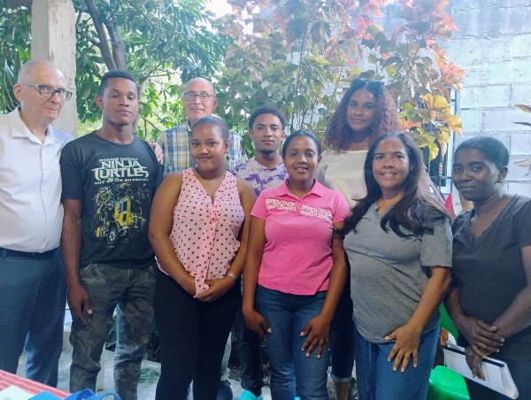
LOS TOROS GOES BACK TO SCHOOL
The school year begins in Los Toros and students who were awarded scholarships (becas) met to sign their contracts. Shown above from left to right are Deacon Donald Kabara, Yoel Suero, Joe Schaub (St. Joseph’s Los Toros Mission Council chair), Loderys Lugo, Smil Beltre, Charleny Reyes, Jessi Rodriguez, Mirella De Leon (chair of the scholarship committee in Los Toros), and Yojairi Ramirez.
Other education projects are also starting up. Among them are after-school tutoring for school children, and aid with bus fare for post-secondary students to go to INFOTEP, a technology and vocational school in Azua, a nearby larger city.
Eleven-year-old Breiny will go by bus to the special school for the deaf in Azua. This past spring, he, his two brothers, and their mother studied Dominican Sign Language with Anthony, a teacher from that school, who came to the Los Toros Library for special classes three days a week.
OTHER LOS TOROS NEWS
- Thank you to all the volunteers and customers who made the Farmers’ Market such a success this summer. This helps with the unexpected expenses.
- Volunteer needed! Can you coach us with a website on WordPress for the mission? Contact Joe Schaub at lostorosmission@gmail.com.
- We will celebrate Los Toros Mission Sunday on the last weekend in September. This annual fundraiser sustains all the services for the people of Los Toros. Watch for our letter to arrive in your mailbox.
For more information about our Los Toros Mission in the Dominican Republic, visit the Los Toros Foundation page on Facebook.
For specific inquiries, email Joe Schaub at lostorosmission@gmail.com.

